Alfonse Borysewicz: Residency Proposal
Charleston, SC | Fall 2026

“Do you understand all these things?” (Gospel of Matthew 13:51)

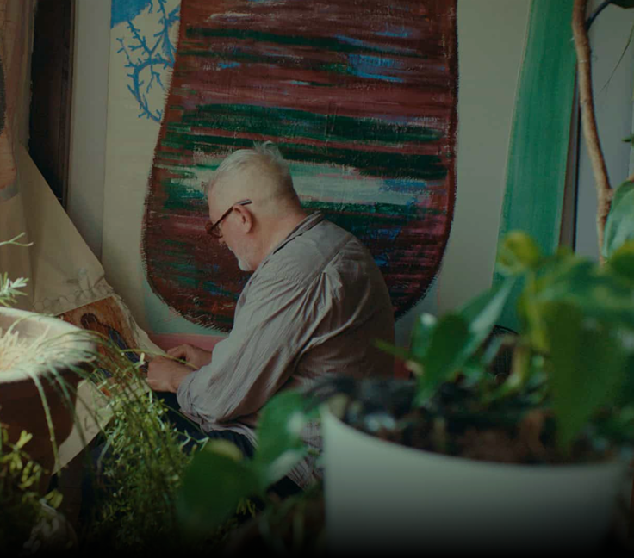
The concept of an "understanding heart" appears repeatedly throughout the Hebrew Scriptures—often in reference to the common or simple person—and is echoed in the New Testament through Jesus’s teachings on the Kingdom of God. In the Gospels, Jesus uses vivid imagery to convey this divine reality, three of which form the foundation of my project: a hidden treasure, a net cast into the sea that instantly fills with fish, and a blind man receiving sight. Each of these episodes brings an abundance to life, illustrating that the presence of God is not something we acquire, but something we discover—or, in Heideggerian terms, unconceal.
Alfonse Borysewicz in the studio.

Understanding this divine presence is not a purely intellectual exercise. Rather, it is an act of discernment that engages the whole person: thoughts, desires, and emotions alike. It is a matter of lifting the veil to reveal the divine at the very center of our lives—a presence that, as St. Augustine famously noted, has always been there ("God is closer to me than I am to myself"). Engaging in the Gospel acts of finding, hauling, and seeing requires intentional effort in the present moment. It calls us to strip away the distractions that prevent us from cultivating an understanding heart—a truth that applies as much to human relationships as it does to art.
To explore these themes visually, I am bringing three "anchor paintings" (already packed and ready to ship) to Charleston, each portraying one of these key images: the hidden treasure, the net at sea, and the restoration of sight. Along with these pieces, I will bring basic art supplies and intuitively work around the imagery in a quiet space—shutting out the "megaphones" of the world. In doing so, I hope to offer an invitation for others to step into the here and now, contributing their own input, presence, and understanding.

